TERM PAPER/SEMINAR

On

ARTIFICIAL INTELLIGENCE

IN MEDICAL IMAGE PROCESSING

CONTENTS

1. Abstract............................................................................................
2. Introduction: an exploration........................................................................................

2.1) Artificial intelligence: need of the hour...................................................................................................

2.2) The 7 aspects of AI.....................................................................

2.3) Artificial intelligence in medicine…………………………………………..

2.4) How AI be used in Healthcare…………………………………………………

2.5) Image Processing......................................................................

1. Objective..........................................................................................

3.1) Basic medical image processing system.................................

3.2) Image processing system using AI technique..........................

3.3) Artificial neural network..........................................................

1. Conclusion.........................................................................................
2. References.........................................................................................

LIST OF IMAGES

1. FIG1: X-ray radiography of a knee.......................................................
2. FIG2: MRI of the head.........................................................................
3. FIG3: Modern CT scanner....................................................................
4. FIG4: Architecture of a neural network...............................................

**ABSTRACT: Artificial intelligence: need of the hour**

Al is a new way to improve healthcare performs to accomplish better outcomes at lower costs. Medical imagining processing is a dawn of the revolution, via encircling plethora of information doctors are way more confident are strengthened and magnified. In the technological world al is a technique and one of its stroke’s is future of imaging processing. Speaking for a nourished, environment ahead. MI is the mere outset of AI.

The study in the field of medical imaging is related to the interaction of all forms of radiation with the tissue. Non-invasive methods are applied in this technique without the help of any surgery. The use of imaging technology in medical science enabled the doctors to see the inside of the body which otherwise would have been a bit difficulty uplt for easy diagnosis of diseases and other abnormalities. It helped doctors and other medical experts to investigate the body’s third dimension properly. Various modalities of medical image processing help doctors to enhance the diagnostic technique without causing stress or pain to the patient. Medical imaging has experienced dramatic expansion and due to its diverse nature of study it attracts researches from different fields. The field being so vast continuously demands time to time development and improvement and therefore the processes involved in image processing are becoming further more advanced as discussed below. The AI technique used in image processing system is less labour and knowledge intensive. Further artificial neural networks are discussed which is an important tool for various algorithms including data compression, segmentation, etc.

**2. INTRODUCTION: AN EXPLORATION!**

2.1 ARTIFICIAL INTELLIGENCE: It is the intelligence possessed by machines. Programs are encoded which enable these machines to match human level intelligence. The machine becomes an agent that recognizes its environment and takes action according to the instructions.   
  
 what exactly Artificial intelligence means to us????

Technically, it’s the need of the hour. The definition of AI keeps on moving evolving, with the revolutions one after the other. Well! It’s an intelligence to understand simple words, crack the terminology in computer science, artificial intelligence (AI) is also known as machine intelligence, is an intelligence exhibited by machines. In distinction to natural intelligence displayed by the humans. Informally the term artificial intelligence is generally used to describe machines that imitate 'cognitive' functions that humans equate with the human mind such as 'learning' and 'problem solving'. The world revolves around technology, in this machine oriented competitve world, AI took the chase. In a broader spectrum AI is nothing but the highlights of the threshold of the third millennium. Artificial intelligence is branched into three sections of systems: analytical, human-inspired, and humanized artificial intelligence.

The strived aims AI research inculcates reasoning, Presentation of knowledge, drafted plans, Learning, Series of speech recognition software, Perceptions, frisking with various objects, advanced Approaches to ai. Many tools are used in AI, including versions of search and mathematical analytics. In a nutshell AI field out lights upon Advancements of computer science, Information techonolgy, Mathematics and   many other fields. AI serves as a helping hand in order to have an analysis of the efficient and effective to diagnose the various diseases, strengthened and magnified advancement of the drugs, variety of personalized treatments, etc…

This will enhance and grow and gradually. The more we digitize and explore the unventured possibilities encircling the medical data  further AI would help us to dig valuable patterns, structures designs, various patterns to help us make pointed ,that help build the cost effective decisions in the complex system analytical processes.

The effects of artificial intelligence and its implications are stapling the mankind slowly and gradually.

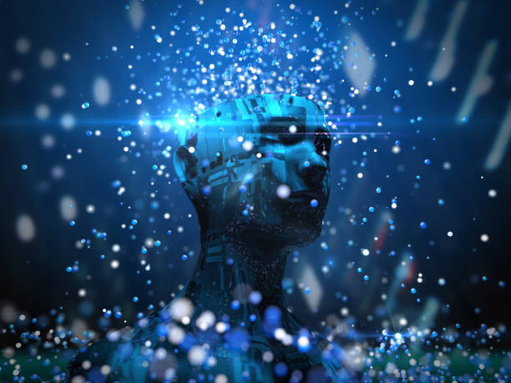 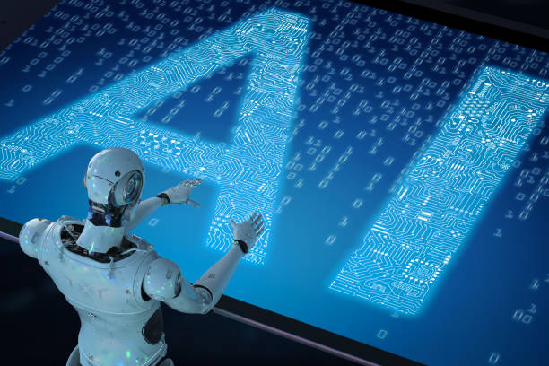

Various aspects of AI…………

1- the expansion of simulation of higher functions of the human brain.

2- A way to determine and measure problems completely and resolve them accordingly.

3- self-improvement in the various spectrums.

4- evolving creation of randomness and creativity

5- programming a computer to use a general language and act accordingly.

6-arranging hypothetical neurons so that they can form the concepts.

7-abstraction: defined as the quality of dealing with ideas other than events.

2.3 AI In medicine: AI in medicine can be explained as the use of AI as a automated process in the diagnosis and treatment of the patients whom require care and to keep data as records through patient tests, analysing results.artificial intelligence in medicine are rooted in the following streams... diagnostics, further upliftment of drugs, personalization of various treatments etc... largely it focusses on the enormous interdisciplinary aspects encircling the theory and implication of artificial intelligence in medicines mainly into 2 sects that is – healthcare and medically oriented effects on the mankind. **ARTIFICAL INTELLIGENCE in medicine**may be based as per the various scientific discipline revolving into the research studies , projects, and applications that hits to blossom the decision oriented medical tasks through knowledge- and/or data-intensive computer-based solutions that would further support and improve the performance of the user (mankind).

Furtherwhich, artificial medicine urges to bringabout .....  
  
• **aims to uplift the high potential impact in medical and the healthcare sections in the technological world.**  
• **Strong implications and theory associated to AI and computer science techniques so that it diverges the scope and plethora of aspects to fluorenscence the mankind, eventually.**

2.4 How AI be used in Healthcare ?

AI in healthcare we can define as it is used to resolve complex algorithms and different software's to evaluate human cognition to examine the complicated medical data. Artificial intelligence would serve as a means to formulate conclusions via computer algorithms without human intervention.Flipping back pages of history, al technology in the healthcare Imbibed ways to gain information, process it and produce a desired output.

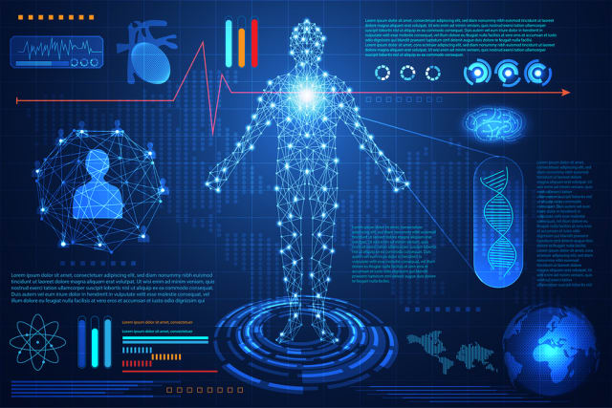

2.5 Image PROCESSING: It is an application of signal processing-a technology which includes processing of information in symbolic form, often designated as signals. Through similar techniques “Image processing” is done using mathematical operations.

An input image is taken either as a2-D signal f(x,y) or as a 3-D signal f(x,y,z) and modified output in the form of an image or characteristic feature of that particular image is produced. This technique is much familiar in the field of medical science, known as “Medical image processing”.

Here the images rooting the interior of the body are dealt in order to do medical analysis for treating plethora of diseases and abnormalities of the patient. Medical imaging has various modalities including X-ray radiography, MRI and CT scans.

X-Ray radiography- It is an imaging technique which is operated through electromagnetic radiation generally X-rays to view the internal structure of any object having a non- uniform density and composition for instance human body. The procedure includes passing of x-ray beams through an x ray generator and is directed towards the object. The x-rays are imbibed by the objects and captured behind them by a detector generally a photographic film or digital detector. The images are a 2-D representation of internal structures of human body in this case. The following figure represents the X ray image of a knee.

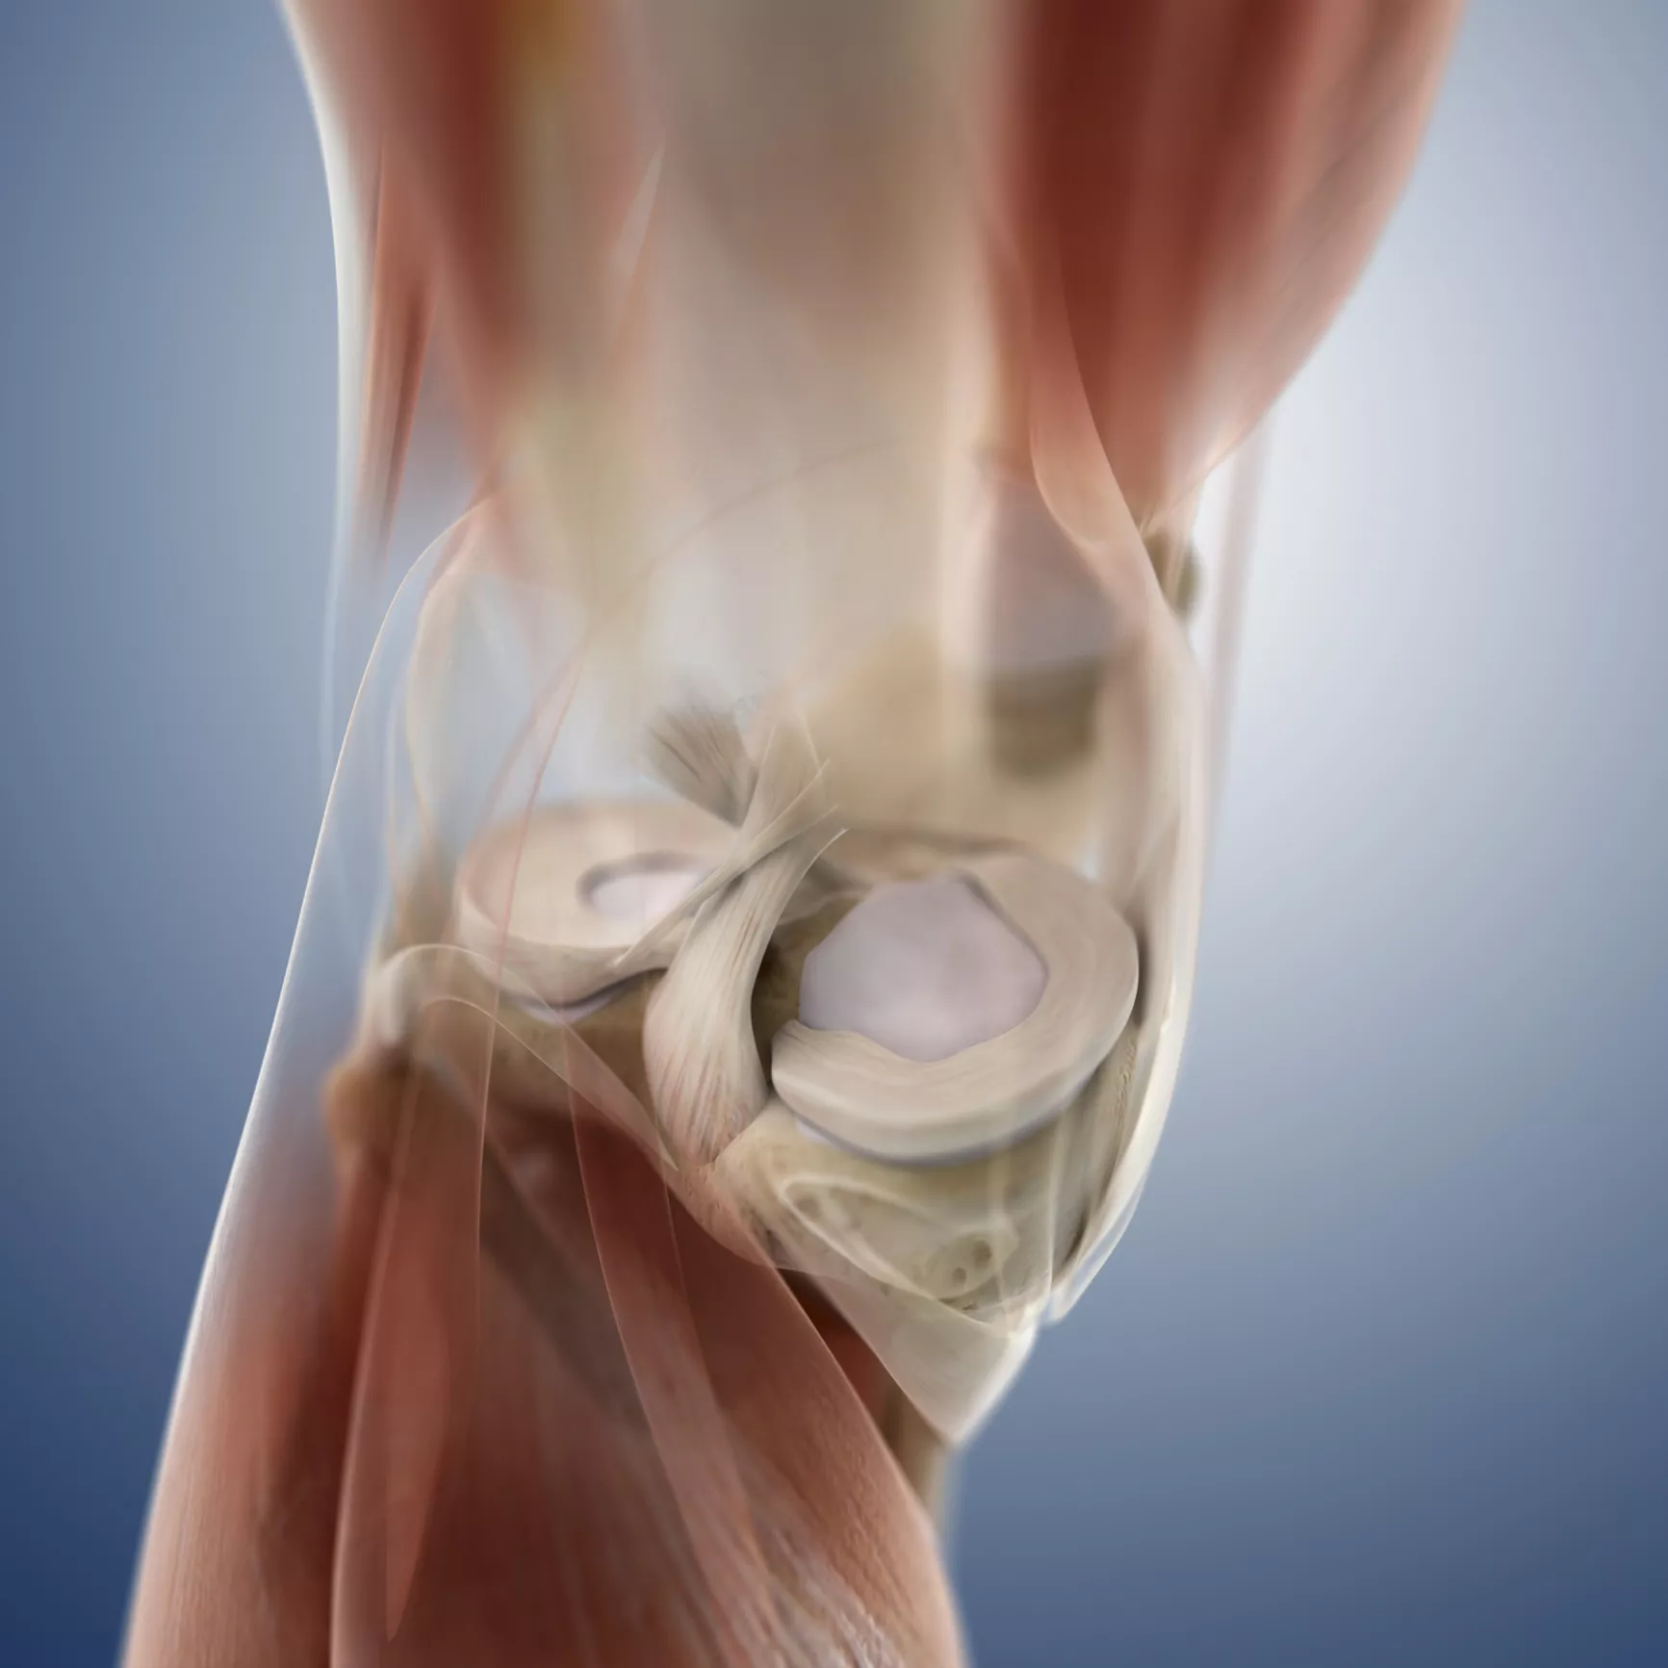

MRI- Short for magnetic resonance imaging as the name suggests is again an imaging technique which works upon radio wave energy to generate pictures of the internal body such as the organs. The procedure includes placing the area of the body which needs to be studied under a strong magnet. Some atomic nuclei can absorb and emit radio frequency energy when placed in an external magnetic field. This is based upon the science of nuclear magnetic resonance (NMR). MRI is a multipurpose and advanced imaging technique, which can even be used to create the images of non-living objects. The following figure depicts the MRI of the head.

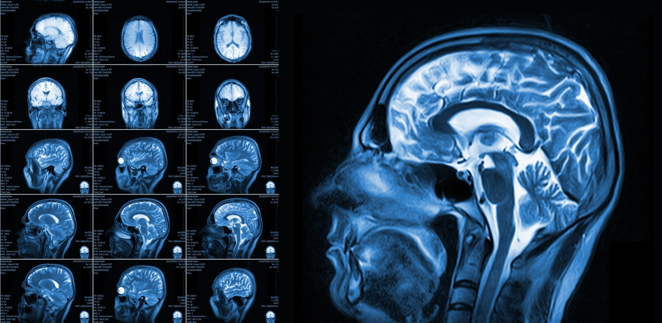

Computed tomography (CT scans)- It is another imaging test used to generate proper images of the internal body structures like organs, bones, soft tissues and blood vessels. CT scanning is still the best way for determining different types and forms of cancers as the pictures depict accurate size of tumours present as well as the location. Unlike in the case of X-ray radiography a 3-Dimensional image of the object is produced by CT scanning.

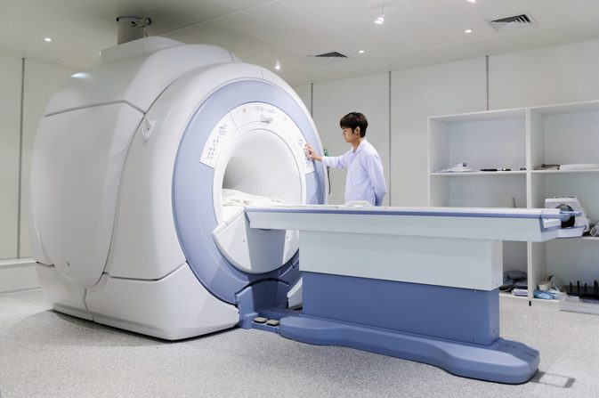

**3. OBJECTIVE**

3.1 BASIC MEDICAL IMAGE PROCESSING SYSTEM:

The initial step includes Image Acquisition - It can be clubbed as the move of recovering of an image from some source, basically a hardware-based source. While image processing is done image, acquisition is the first step followed by other steps.

Secondly, processing of images is done which includes further smaller steps like:

* Pre-processing
* Segmentation
* Detection
* Analysation
* Diagnosis of the image

further which, final reporting of the processed image is done.

3.2 IMAGE PROCESSING SYSTEM USING AI TECHNIQUE

The above-mentioned process is both knowledge as well as labour intensive. It takes a scientist or a researcher many years of experience to posses’ sufficient amount of knowledge to carry out these analyses, putting these experts in high demand. One may expertise in one field but not in all the areas related to image processing.

To solve this problem, automated planning technology is used to represent and automate many of the data analysis function. Planning technology depends on encoding of possible actions in the domain. In this encoding, each and every action is defined in the domain. Actions include:

Preconditions: - They are the conditions that need to be fulfilled before the analysis is made.

Post conditions: - They are the conditions that are met after the execution of the actions like (image formatting, etc).

Sub activities: - They are lower level activities that comprises of higher-level ones. The planner with the help of its action models executes a plan to achieve targets from the current state. Planning comprises of three main mechanisms: -

1) Subgoaling-Through this process it is ensured that all the preconditions of the action in the plan are met.

2) Task decomposition- Through this process, the planner looks forward to ensure that all the sub activities are done.

3)Conflict Analysis- The process ensures that different portions of the plan do not contradict or interfere with each other.

The automated image processing system short for ASIP automates Synthetic aperture radar (SAR) image processing using AI automated technique. SAR is a form of radar which is used to obtain images of objects such as landscapes. The images obtained are either 2 or 3 dimensional ones. SAR is fitted over the moving platform like spacecraft or aircraft, it targets its region to provide finer spatial resolution than it is possible with normal radars. It is a rule that as large the aperture (size of the antenna) is, the higher the resolution of image will be. Thus, a high-resolution image can be created through SAR.

Medical imaging can be done using two ways either using film radiographic technique or the digital imaging technique.

The former includes the exact same procedure as performed in the case of X-ray radiography. However, the functions are performed using emulsion gelatine.

The later comprises of electromagnetic waves having variable attenuation. As they pass through objects, they convey information which constitutes into an image. Information is converted into digital signals by image sensors outputted as visible light image.

DIPE: Short for distributed environment for medical image processing it provides image processing services over integrated teleradiology services network. This includes transferring of patient images generated through either of the form of medical image processing between various radiologists and physicians for the purpose of sharing studies. This method enhances the radiology services given to the patients. Radiologists need not to be present at the location where patient is, in order to provide the respective treatment.

3.3. ARTIFICIAL NEURAL NETWORK (ANNs)

It comprises of input layer of neurons, some hidden layer of neurons and output layer of neurons, interconnected through lines wherein each connection is associated with a numeric value known as the ‘weight’. Below is the diagram representing architecture of a neural network.

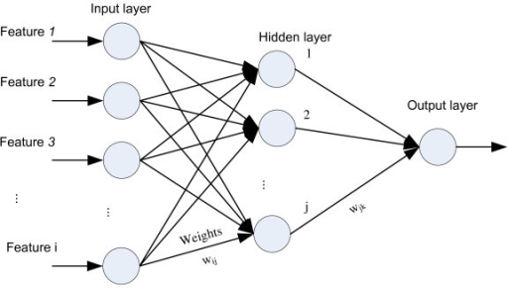

Fig4: Architecture of a neural network.

Artificial neural networks are specified using three things-

Architecture- It describes what variables should be included in the network and their topological relationships

E.g.-: Weights may be the variables involved in the neural network.

Activity Rule-It depends upon the weights in the network, activity rules define how the activity of the neurons change in response to each other.

Learning Rule- It describes the way in which the neural network’s weight changes with time. Generally, the learning rule depends upon the activities of the neurons.

The artificial neural network tool can be applied in the fields where function needs to be deduced from the observation. Its real-life applications include functional approximation, data processing, robotics as well as the image processing systems. Artificial neural network is the computational intelligence technique which interprets information with some imperceptibility about the tasks involved in image processing consisting pre-processing of images, data compression, segmentation, etc. ANNs have been used widely for image processing since the 1950s. Artificial neural network in the field of image processing applies to the following subjects: Shape segmentation in medical images, cell and tissue extraction and recognition in biological images, biometric patterns and gestures extraction, sensing through imaging in productive process and remote sensing, automated traffic control and security etc.

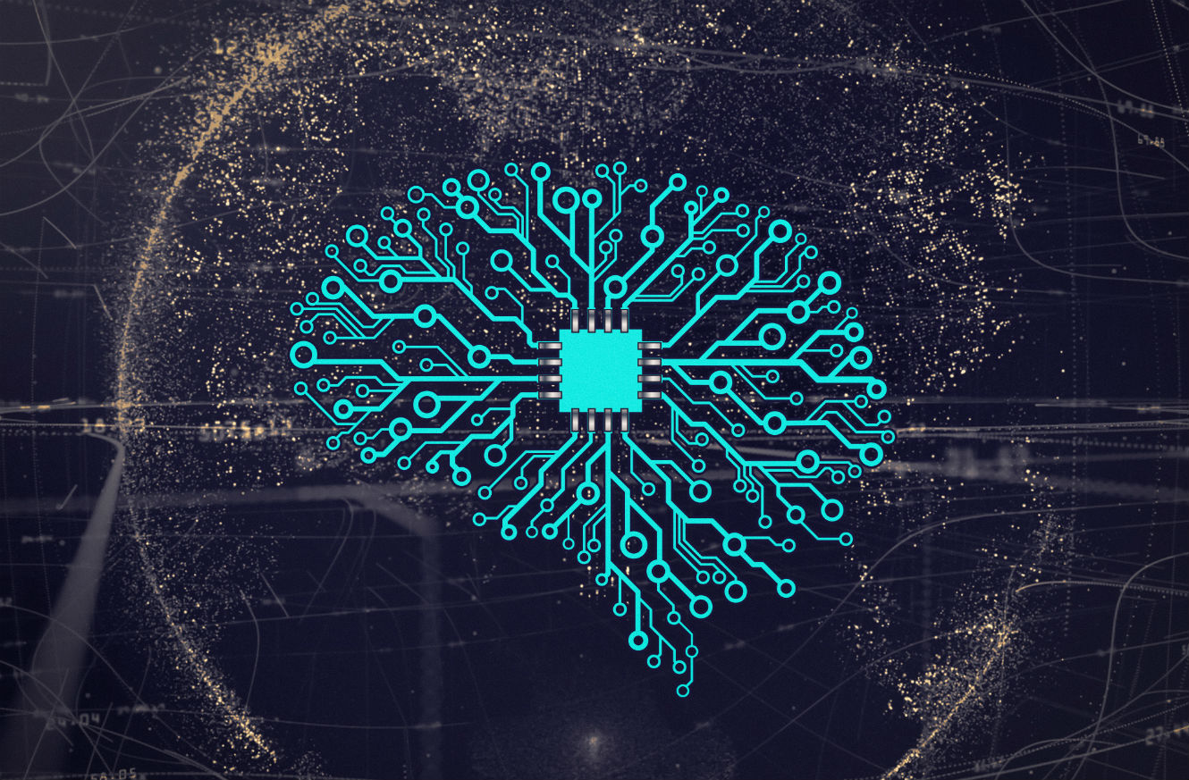

**5. CONCLUSION**

In a nutshell, I’d like to enlighten you up with the basic medical imaging process as well as the image processing using artificial intelligence. Modalities encircling x-ray radiology, MRI’s and CT-scans, illuminated it. Concluding about these modalities the best way of image processing in the field of medicine is through CT scanning as it produces a 3-dimensional image thus, lit the exact size and location of the tumour detected. Further which, the DIPE short for distributed environment for medical image processing which is a platform where radiologists from all over the world interact in order to study and discuss various issues for better treatment of the patients for a nourished and efficient tomorrow. Artificial neural networks is thrown light upon with the enhancements in the outer revolution day after day, min by min, sec by sec, life processes accordingly, and we human condition in accordance to the change imprinted on us. The field being a vast one requires time to time changes and advancements which is stapling the mankind alike spirit slowly and gradually

**6. REFERENCES**

1. Olczak, Jakub, et al. "Artificial intelligence for analyzing orthopedic trauma radiographs: deep learning algorithms—are they on par with humans for diagnosing fractures?." *Acta orthopaedica* 88.6 (2017): 581-586..

2. El-Dahshan, El-Sayed Ahmed, Tamer Hosny, and Abdel-Badeeh M. Salem. "Hybrid intelligent techniques for MRI brain images classification." *Digital Signal Processing* 20.2 (2010): 433-441..

3. Hosny, Ahmed, et al. "Artificial intelligence in radiology." *Nature Reviews Cancer* 18.8 (2018): 500.

4. Ramirez-Quintana, Juan A., Mario I. Chacon-Murguia, and JoseF. Chacon-

Hinojos.”Artificial neural image processing application: survey.”*Engineering*

*Letters* 20.1(2012):68.

5. Zikos, Marios, Eleni Kaldoudi, and Stelios C. Orphanoudakis.”DIPE: A

Distributed Environment For Medical Image Processing.”

6. Wang, Sun-Chong.”Artificial neural network.” *Interdisciplinary computing in*

*Java programmimg.* Springer US, 2003.81-100.